Introduction to the Aquila Voxlab 3D printer

**At the current moment the 3D printer only prints in PLA**

To use this 3D printer, first install the latest version of [UltiMaker Cura](https://ultimaker.com/software/ultimaker-cura), a slicing tool for 3D drawings.

Next is to install the custom designed Aquila Voxlab 3D printing profile by following the steps shown below

1. Get the printer profile from the micro SD-card, which resides in the 3D printer tool box
2. Open Cura and go to **Add Printer**

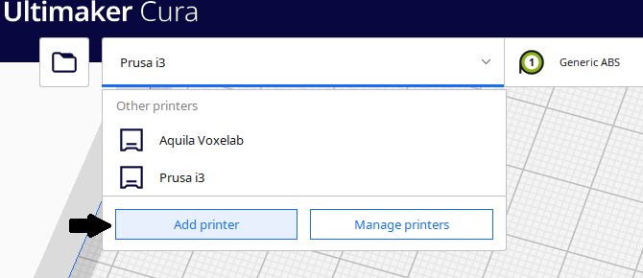

1. Select **Custom Printer FFF**, rename to **Voxelab Aquila,**then **Add**

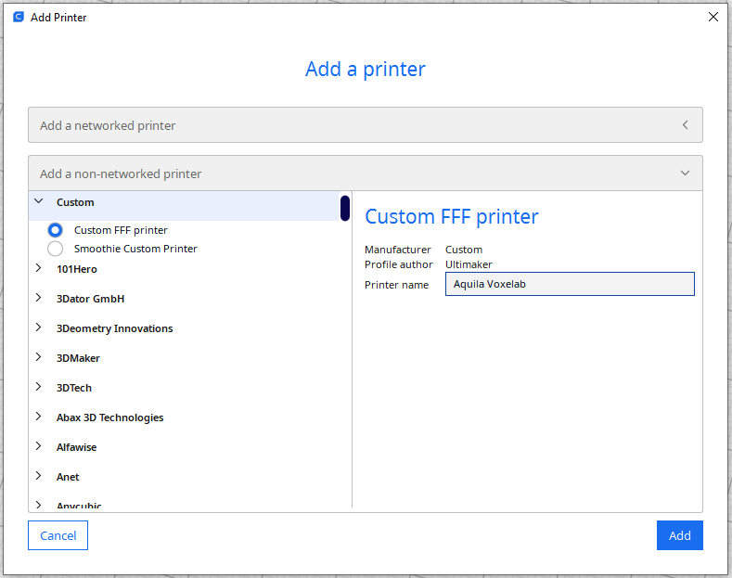

1. Go to **Manage Printer>Machine Setting**

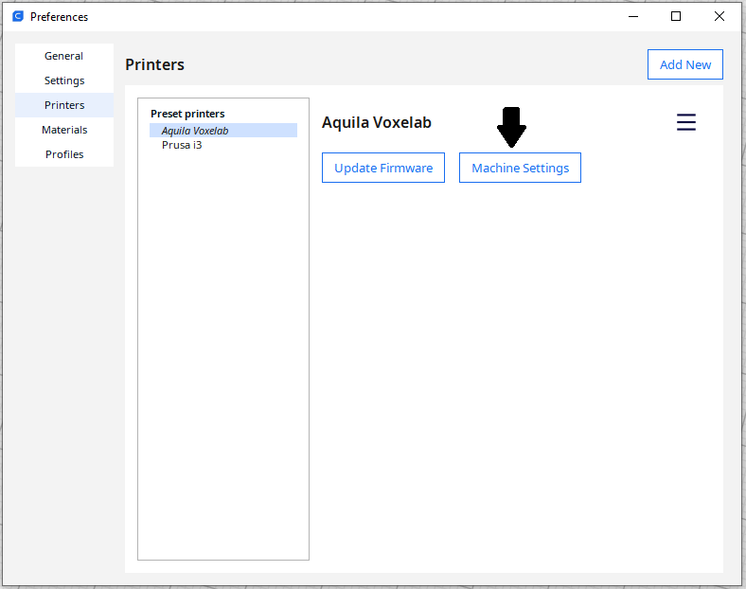

1. 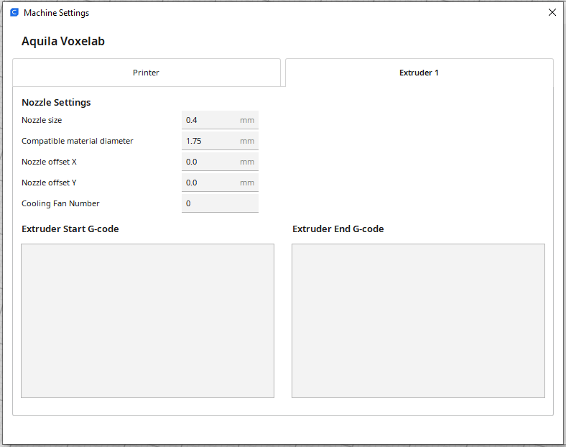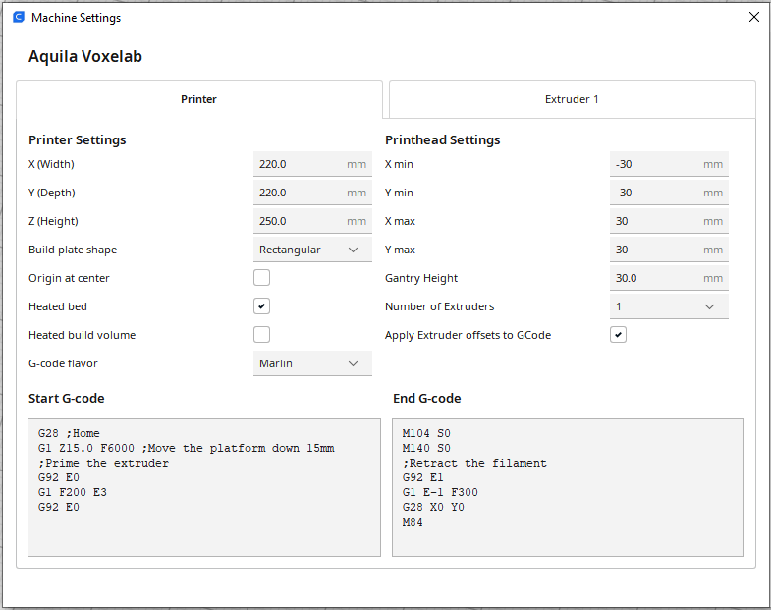Apply these settings below
2. Go to **Manage Printer>Profiles** and import the printing profile you got from the SD-card

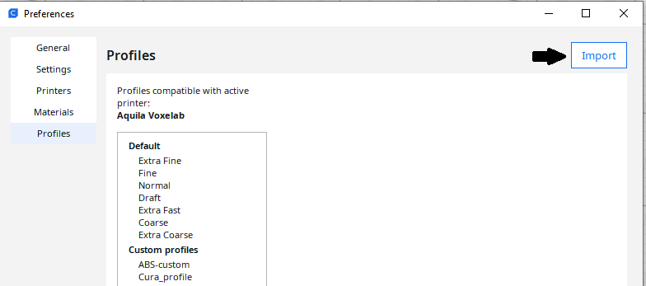

## Quick guide to getting started

Upload the file by pressing the folder button in the top left corner or simply drag and drop your .stl file in Cura

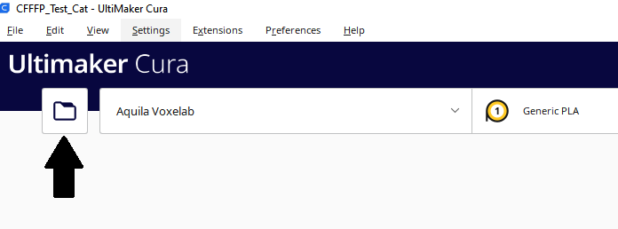

Change the settings as needed, see *changing settings*

Press the slice button at the bottom right corner, when done with the settings.

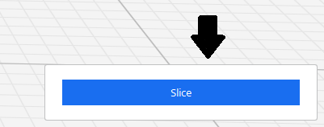

Save to the microSD-card and eject it.

Place the microSD-card into the printer in the slot found on the left side on the printer.

Turn on the printer

By using the knob, press down on the print category on the printer.

Find your print by turning the knob and then press down to start the print.

If you immediately can see that there either is a problem with the print being wrong or the 3D printer not behaving correctly press the knob down again and you can stop the print.

If the problem is the 3D printer please see *Troubleshooting*

## Changing settings

While there are a lot of settings that you can configure in Cura, please refrain from changing more than the basic settings. Usually, you won’t need to change more than Layer height, infill, support and nozzle temperature to get your desired result. With infill density it is important to remember that it barely impacts the strength of the print beyond the 50% point and usually as low as 10% is enough.

The settings should be changed within the range given below:

Layer height: 0.1 – 0.4 mm

Infill Density: 5 – 50 %

Infill Pattern: Any type you want

Support: on - off

Temperature: 190 – 210 °C

[What type of infill should I use?](https://www.wevolver.com/article/cura-infill-patterns-what-they-are-and-when-to-use-them)

[How do I use support?](https://all3dp.com/2/cura-support-settings-optimize-your-supports/)

If you have questions about the 3D printer feel free to contact the current 3D printer super-users, however, we **cannot** help with the drawing process.

Thorbjørn : [tbj@bce.au.dk](mailto:tbj@bce.au.dk)

# Troubleshooting

Problems with the 3D print either not sticking to the bed or the print leaving an imprint on the bed:

The reason for the 3D print not sticking could either be that the nozzle is too high above the bed or the bed simply has lost some of its gripping ability. The first thing is to try and clean the bed in isopropyl alcohol. If that doesn’t work and you suspect bed leveling might be the problem, please read the following link to get an understanding of how bed leveling impacts a 3D print:

[Information post about nozzle height](https://1.bp.blogspot.com/-3xmubC2tibQ/XTMRWdUBy5I/AAAAAAAAJb0/ehE1RTpabpAiv7Y0MQxZ59fkY62LbtFTgCLcBGAs/s1600/3d%2Bprinting%2Bbed%2Bleveling%2Bguide.jpg)

Bed leveling is done by going into control and move the extruder head directly over each of the four bed leveling gears. Their coordinates are:

**X 25 - Y 30**

**X 195 - Y 30**

**X 25 - Y 200**

**X 195 - Y 200**

**Important note on next page ->**

**IMPORTANT NOTE**: **Remember to move the Z axis 2 mm above the bed when going to a spot, otherwise you might scratch the bed resulting in permanent damage**. Manually readjust each gear until the distance between the nozzle and the bed is 0.1 mm, which corresponds to two A4 sheets. Meaning, if you take two sheets of A4 paper under they should just about go free of the nozzle. Check the bed level by going between each of the gears until you don’t have to readjust them, could be up to 3-4 times.

Test the bed level by using the 3D print “Bed leveling”. The print should show an even print, which sticks to the bed.

[How to calibrate a 3D printer](https://teachingtechyt.github.io/calibration.html#intro)